20th November 2017

**WTCC Macau brings title decider to the last rounds**

The FIA World Touring Car Championship which boasts the Japanese Tyre manufacturer YOKOHAMA as Official Tyre supplier visited the demanding Guia street track in Macau at the weekend.

As usual, the Race of Macau, did not disappoint the fans. Drama as expected unfolded following several race incidents which made the teams work extra hard on repairs and ensuring the cars were able to be race-worthy, after several crashes in the Guia street circuit. The weather conditions also made the race exciting as ever with rain appearing too. Once again Rob Huff, was able to engrave his name in the golden history of the legendary race by achieving his record breaking 9th win in the main race. “Huffy” was closely followed by Norbert Michelisz and Tom Chilton in third and the argentine Esteban Guerreri in 4th.

Before that it was Mehdi Bennani who took the advantage of the reverse grid to lead all the way from pole position to claim victory in the shorter than usual Opening Race. Title contender Norbert Michelisz was involved in a crash that stopped the action early with just 5 of the scheduled 8 laps completed. Michelisz’s Honda Civic blocked the track and everybody else behind him and with no option to pass, the red flag was waved and results called. Bennani was followed by veteran Tom Coronel and Ryo Michigami, who bagged his maiden podium and valuable points for Honda in the Manufacturers Championship.

As the Championship heads to Qatar next for a thrilling finale with three prestigious titles still up for the taking, several drivers still have an open chance of overall success. Thed Björk heads Norbert Michelisz by 6.5 points in the battle to win the FIA World Touring Car Championship for Drivers, while Volvo Polestar heads Honda by 12.5 points in the race for the FIA World Touring Car Championship for Manufacturers. The WTCC Trophy, which aims to support non-works teams is also hot at the top with Tom Chilton just half a point ahead of his Sébastien Loeb Racing team-mate Mehdi Bennani, while Rob Huff is also firmly in contention, seven points behind Chilton.

All shall be decided at the Race of Qatar, 30 November - 1 December.

Driver Championship current standings:

1 Thed BJÖRK 255,5 pts

2 Norbert MICHELISZ 249 pts

3 Mehdi BENNANI 216 pts

4 Nicky CATSBURG 211,5 pts

5 Tom CHILTON 210,5 pts

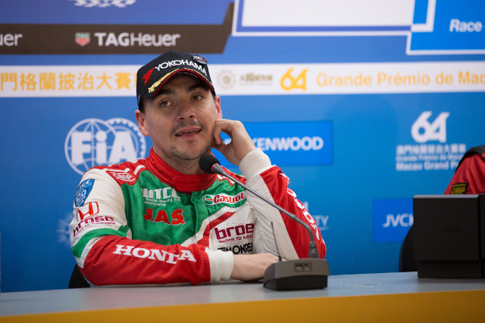

*Michelisz still in the running for the WTCC Glory*

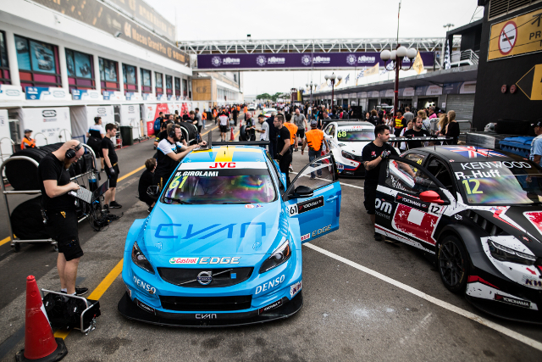

*Ready for action at WTCC Macau with YOKOHAMA tyres*

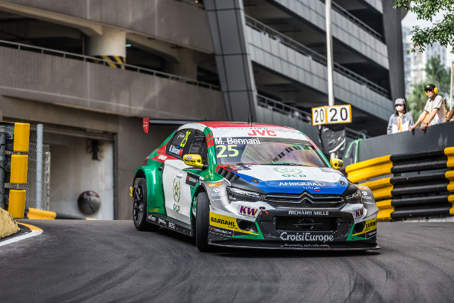

*Success for Bennani in Macau 2017*